**Different Patterns of Local Field Potentials Lead to a Response in False Alarm and Hit Trials of a Sensory Detection Task in Mice**

Abstract

In this project I analyse the local field potential (LFP) recorded in different brain regions during False alarm (FA) and Hit trials of a sensory detection task. In FA trials but not in Hit trials, the time of maximum late depolarisation recorded in the secondary somatosensory cortex (wS2) and in the primary motor cortex (wM1) can be used to predict response time. There was no late depolarisation, which has been associated with stimulus perception, in FA trials, excluding the possibility of a false stimulus percept. This suggests that different activity patterns lead to a response in the presence or absence of a stimulus. Additionally, an increased hyperpolarisation observed in late FA trials in the wS2 suggests a role for the wS2 in learning.

Introduction

Determining representation in the brain is a difficult task and interpretation of results vary depending on the accepted definition (Baker et al., 2021 - preprint). Behavioural task are a common framework in which to study neural representation. In the paper Sachidhanandam et al. (2013), the authors used a detection task in order to investigate representation of sensory stimuli in the layer 2/3 of the primary somatosensory cortex (wS1). Mice had to produce a response when presented with a stimulus. Trials were categorised as: hit (stimulus and response), miss (stimulus, no response), false alarm (FA) (no stimulus, response) and correct rejection (CR) (no stimulus, no response) (Figure 1B). In juxtasomal recordings made during hit trials, neurons displayed a long and weak depolarisation 50-400 ms after stimulus onset, which was significantly attenuated in miss trials. As this later depolarisation precedes the response, the authors suggest that it participates causally to the response and is indicative of the perception of the sensory stimulus. A follow up paper (Le Merre et al., 2018), measured the LFP in several more regions during the same behavioural task. In addition to the wS1, the authors recorded from the wS2, the wM1, the associative parietal areal (PtA), the dorsal CA1 region (dCA1) and the medial prefrontal cortex (mPFC).

Both papers look at the pattern of activity in miss and hit trials but leave out FA trials from their analysis. Determining the pattern of activity of neurons during FA trials may shed some light on the strategy employed by the brain to produce a respond and the link between stimulus perception and behaviour. The aim of this project is to uncover the pattern of activity leading to FA trials and to relate those to Hit trials. For this, I compare the LFP of neurons in FA trials to hit and CR trials, using the data collected in Le Merre et al. (2018).

Methods

**LFP data processing:**

Within the dataset, I selected 11 mice (from 14) trained on the detection task, and the recordings from all regions but the PtA. The number of mice per region used in this project is thus: n(wS1)=10, n(wS2)=8, n(wM1) = 5, n(dCA1)=8, n(mPFC)=8.

The total recording length used was of 2100 ms (of which 100 ms before stimulus onset) with a recording frequency of 2k Hz. The recordings were band-passed between 0.1 and 100 Hz. After, I applied a baseline correction for every trial, 50 ms before stimulus onset.

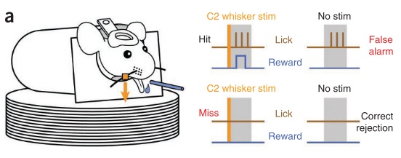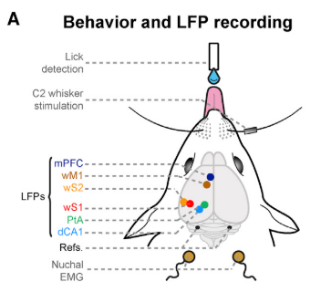

Figure 1: Behavioural task and recording set up

**A**. Set up showing the placement of the recording electrodes and of the placement of the mouse in relation to the whisker stimulation and licking rod. Taken from Le Merre et al., 2018

**B**. Schematic of the scenarios leading to the different task categories. Taken from Sachidandam et al., 2013

**A**

**B**

**Wilcoxon Signed Rank test**

In order to compute the difference between the different trial conditions and between the early and late trials, I used the non-parametric Wilcoxon-signed rank test. This test was preferred to a paired t-test, as a normal distribution could not be assumed for each condition. This is in part due to the small sample size, which was determined by the number of available mice.

Equation: Test statistic W for the Wilcoxon Signed Rank Test

$$W=\sum_{i=1}^{N}{\left(\operatorname{sgn}\left(x_{2,i}-x_{1,i}\right)Ri\right)}$$

N: Number of pairs, x: Data points, Ri: Rank of pairs

I first tested the difference between FA-CR trials and FA-Hit trials, using sessions from all available mice for each region. I then tested the difference between the LFP during FA trials between early and late training days. I categorised the first 3 training days as early training days and sessions after the 6th day of training as late training days. For each, test the mean amplitude was calculated 50 ms at a time, for each mouse.

**Linear Regression**

The average LFP was calculated for 20 trials at a time, which were binned together with respect to their response time. The average response time for each trial group was then plotted against the time of maximum depolarisation, which was extracted from each averaged LFP, excluding the first 100 ms after the stimulus. Linear regression was conducted on datasets which showed a trend towards linear regression. The data was assumed to be independent, normally distributed, and homoscedastic. Each dataset was randomly separated into a train and test set with an 80/20 ratio. The linear regression was fitted to each training set and assessed using the test set. The measures used assess the fit of the linear regression were the root mean squared error (RMSE) and the coefficient of determination (R2).

Results

To first assess the LFP characterising a FA response, I plotted the average LFP for each condition in each region and compared the amplitude of the LFP between Hit, CR and FA trials (Figure 1). In both the wS1 and the wS2, the LFP during FA trials is significantly (p <0.05) more depolarised than the LFP during CR trials between 350-750 ms. In the mPFC, the LFP during FA is more depolarised than in the CR condition between 300-1500 ms, and in the dCA1 between 550 -1400 ms. In the wM1, no significant changes between either FA, CR or Hit trials can be observed, though notably, the LFP from the FA and Hit trials are almost undiscernible after 450 ms. This is also the case the dCA1. Early activity measured from the local field in wS1, wS2, mPFC and dCA1 seem to drive a FA response during the behavioural task.

I then looked at the difference in the LFP during FA trials between early training sessions (first 3) and late training days (all sessions past the 6th one) (Figure 2) to assess if a response in absence of a stimulus is processed differently after learning the task. In most regions, the LFP during late training days is not more depolarised than during early training days suggesting that the FA response is not driven by a false stimulus percept and that the depolarisation observed early in FA trials is not due to a false percept either. In the wS2 however, the LFP is consistently more hyperpolarised than in early trials after about 650 ms. This suggests that there may be learning occurring in the wS2 relating to the FA response.

Building on the previously described results, I tested whether a response can be predicted from the amplitude of the LFP in either condition. Figure 3 shows raster plots of the LFP during hit and FA trials, sorted from shortest to longest lick time. Trials are binned together, depending on their response time. In hit trials for all regions except in the dCA1, there is a strong depolarisation before lick time. The depolarisation seems to get wider as the response latency becomes longer. In FA trials, depolarisation in the LFP is more diffuse. Notably, there was no relationship between training level and lick time (data not shown).

To measure the relation between neural activity and lick time, I plotted the average response time vs the time of maximal late depolarisation for each group of 20 trials for each region (Figure 5). In hit trials for all regions there doesn’t seem to be a correlation between the maximum depolarisation and the response time. For FA trials in wS2 and wM1, there seems to be a linear relationship between the time of maximum depolarisation and response time, so I fitted a linear regression on the data (Table 1). In the wS2 and wM1, response time can be predicted from maximum depolarisation with R2 = 0.62 and 0.85 respectively.

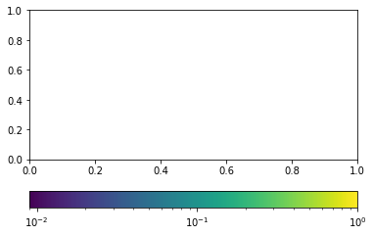

Figure 2: LFP recordings from FA trials differ from CR trials over time.

For each region, the upper panel shows the average LFP for Hit (green), Miss (red), FA (blue) and CR (yellow) trials for all sessions and all available mice. Standard error (SEM) is indicated by a shaded area around each trace. The grey bar indicated time of stimulus application. The lower panel indicates the p-value calculated using the average LFP amplitude over a 50 ms time window for either FA and Hit trials (FA-Hit) or FA and CR trials (FA-CR)

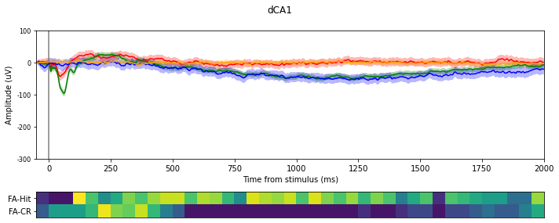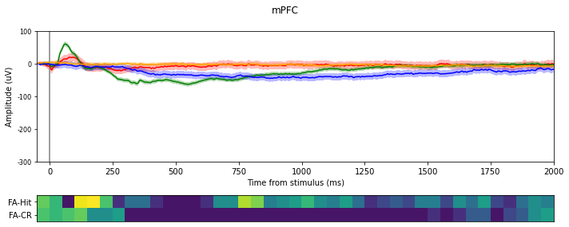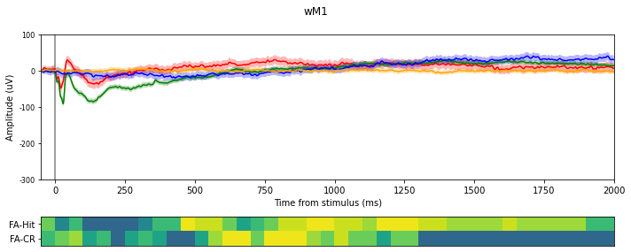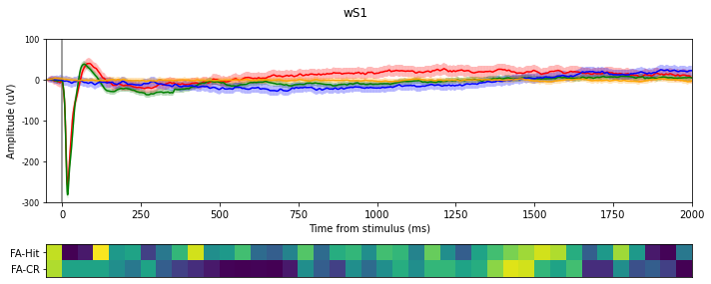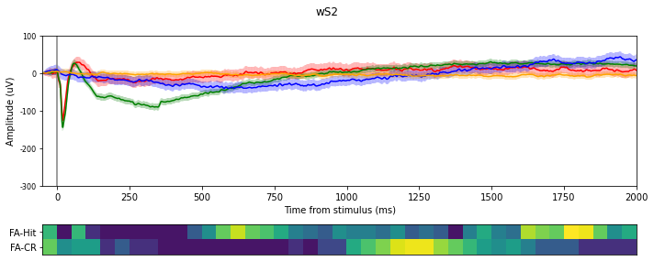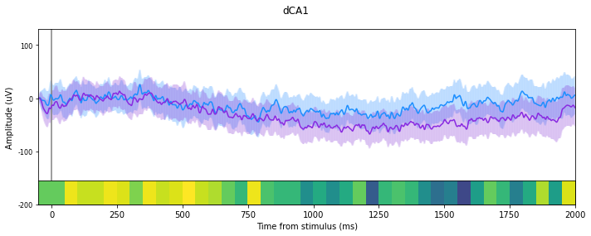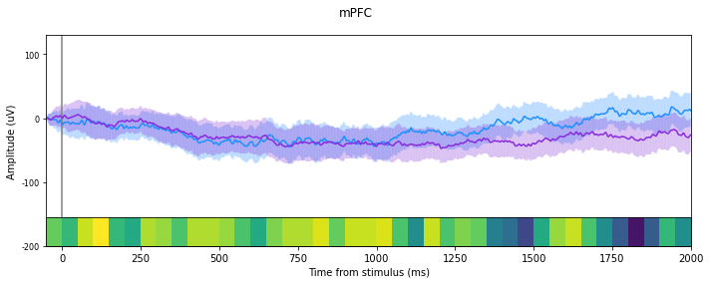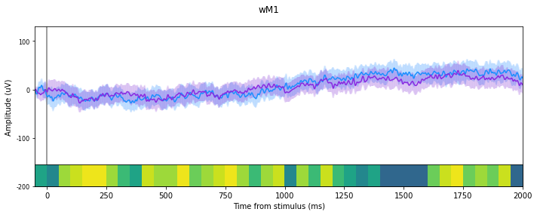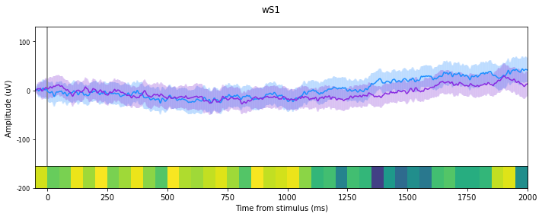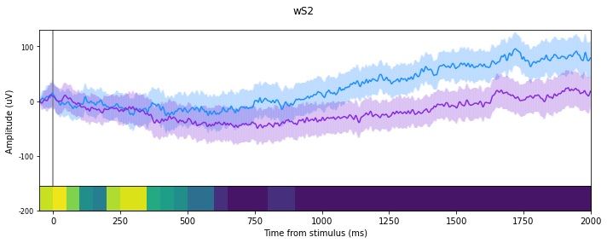

Figure 3: LFP recording from FA trials differ between early and late days in wS2.

Average (+/- SEM) LFP during early (purple) and late (light blue) FA trials plotted for each region. P-values describing the difference between early and late trials within a 50 ms time window are recorded in the colour bar under each plot.

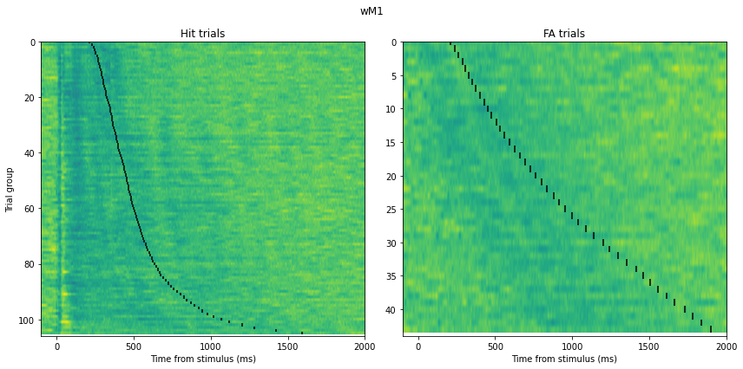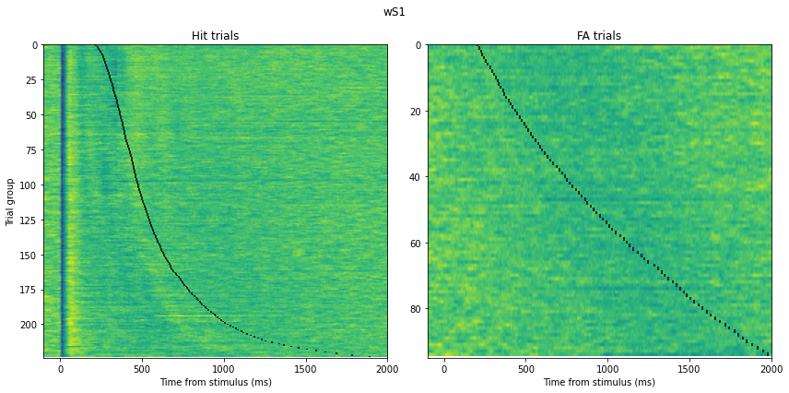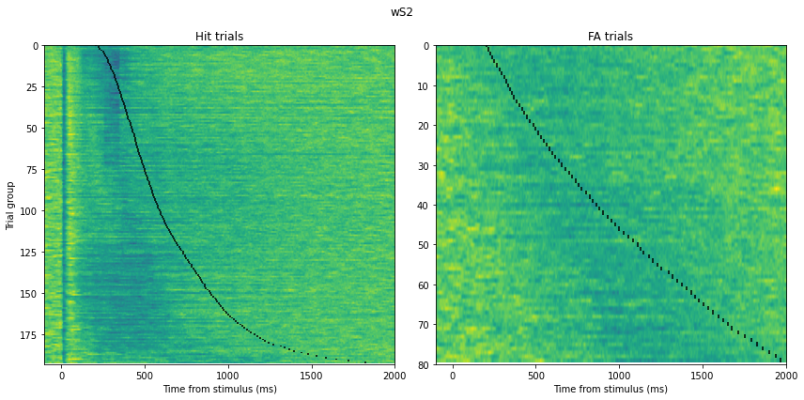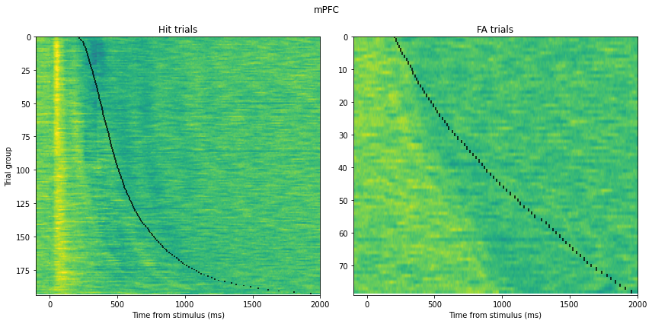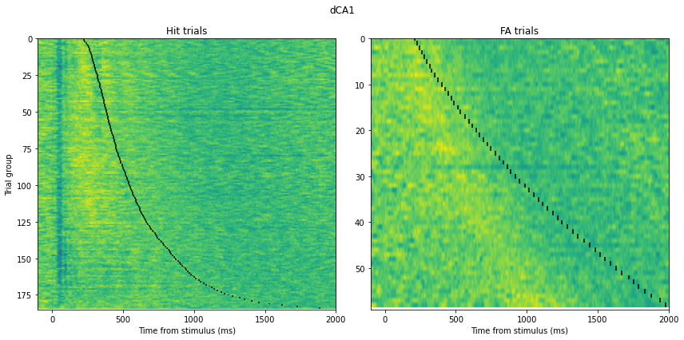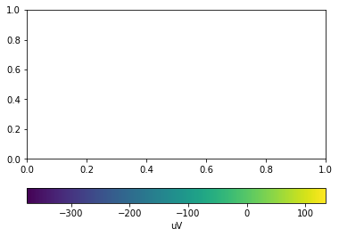

Figure 4: Relationship between LFP and Response time in Hit and FA trials.

Each panel describes a raster plot of the LFP recorded in each region for either the Hit or FA condition. LFP amplitude is colour-coded according to the colourmap at the bottom of the figure. Trials were binned together (n=20) according to their response time and each row shows the average LFP for each group of trials. Trial groups are sorted from fastest to longest response time. The average lick time is indicated in black for each trial group.



Table 1: Linear regression of response time as a function of maximum depolarisation for data in the wS2 and the wM1 for the FA condition.

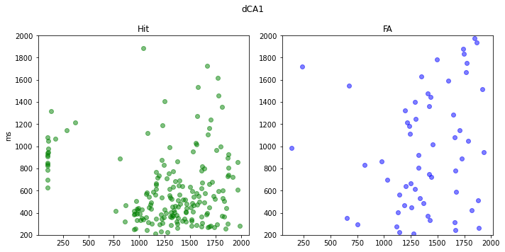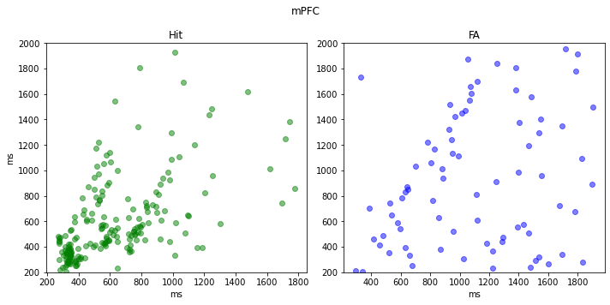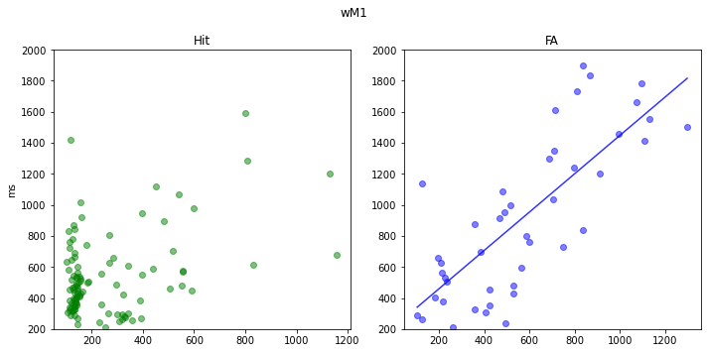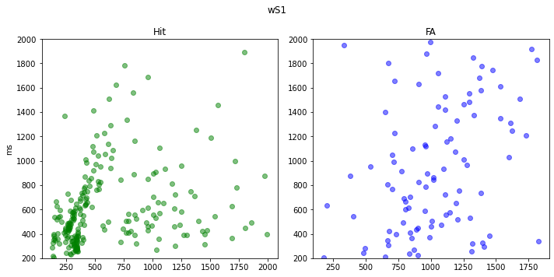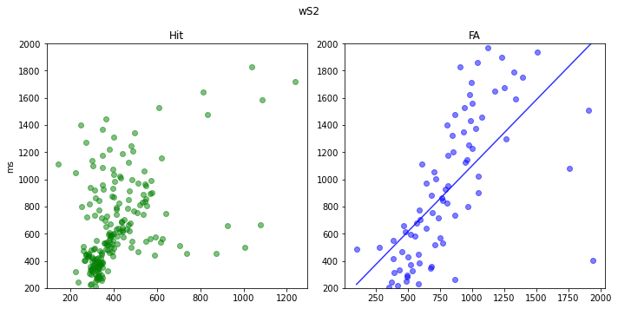

Figure 5: Relationship between maximum depolarisation and response time in all regions for Hit and FA conditions.

The y-axis denotes the response time and the x-axis denotes the time of maximum depolarisation. The maximum amplitude is taken from the average of 20 trials, pooled together depending on their recorded response time. A linear regression was performed for the data in the WS2 and the wM1 for the FA condition.

Discussion

Results show that the error signal leading to FA response occurs at the earliest around 300 ms in the mPFC. However the LFP during FA trials does not directly follow the pattern of Hit LFP in most regions. While there was a relationship between maximum depolarisation time and response time in wS2 and wM1 for FA trials, the data did not resemble that of Hit trials, for which no such relationship was found. This suggests that different patterns of activity are responsible for producing a behavioural response in FA and Hit trials. Additionally, there was no late depolarisation around 100-400 ms in either wS1 or wS2 for FA trials. Seeing as this depolarisation is associated with the stimulus perception in Hit trials, there is further evidence that response is driven by different factors in FA and hit trials. Finally, the LFP recorded in the wS2 was more hyperpolarised in late than early FA trials. The function of wS2 in rodents remain relatively elusive, though neurons from the area have been found to process the remembrance of a past stimulus (Condylis et al., 2020), both suggesting a role in learning stimulus associations.

The size of the data presented an important limitation in the project. In order to load the data I had to remove 3 mice from my data pool and remove one region, the PtA from the analysis. It also limited the use of more tools such as the EMG data, which records the brain state of mice during each trial. Further experiments could explore whether brain state could contribute to the production of a FA response using the EMG data.

Acknowledgements

All data was produced and made available by the Petersen lab. I would also like to thank Harsha Gurnani for help with data pre-processing.

Appendix

Further methods

**Data availability**

The data used can be found on the CERN Zenodo database under: <https://zenodo.org/record/1063898#.YF3zia_7TIX> and corresponds to the ‘chronic_LFP.mat’ file, containing all LFP recordings and relevant information. All the analysis and data visualisation was done in python. All the data analysis and figures were done using python and the code is available at: <https://github.com/isagarnreiter/Neur0019>

**Behavioural task**

The behavioural task used is a simple sensory detection task in which a mouse is trained to respond a stimulus (Figure 1A). The stimulus consisted of a 1ms magnetic pulse creating a vertical deflection on the C2 whisker. Mice responded by licking a small metal waterspout which dispensed sugary water, within a 1 second timeframe of stimulus application. Trials with and without stimulus were intertwined during a session with a 50% probability. Hit trials in which the mouse licked too early (<200 ms) were excluded.

Bibliography

Baker, B., Lansdell, B., and Kording, K. (2021). A Philosophical Understanding of Representation for Neuroscience. ArXiv.

Condylis, C., Lowet, E., Ni, J., Bistrong, K., Ouellette, T., Josephs, N., et al. (2020). Context-Dependent Sensory Processing across Primary and Secondary Somatosensory Cortex. Neuron *106*: 515-525.e5.

Merre, P. Le, Esmaeili, V., Charrière, E., Galan, K., Salin, P.A., Petersen, C.C.H., et al. (2018). Reward-Based Learning Drives Rapid Sensory Signals in Medial Prefrontal Cortex and Dorsal Hippocampus Necessary for Goal-Directed Behavior. Neuron *97*: 83-91.e5.

Sachidhanandam, S., Sreenivasan, V., Kyriakatos, A., Kremer, Y., and Petersen, C.C.H. (2013). Membrane potential correlates of sensory perception in mouse barrel cortex. Nat. Neurosci. *16*: 1671–1677.